Table of Contents
Background 1
Order in which to load the ‘Data Loading’ Payroll files 1
Maintaining Uplifts to Salaries (Load Employee rate file) 2
Loading Uplifted Salaries 2
1. Manually Upload - The columns required are for Pay Grade Scale Point File functionality: 2
Back-out Procedure 3
2. Upload Functionality - The columns required are for Pay Scale Point File functionality: 3
Back-out Procedure 3
3. Upload Functionality - The columns required are for Position Rate Details File functionality: 4
Back-out Procedure 4
4. Upload Functionality - The columns required are for Employee New Rates of Pay functionality: 4
Back-out Procedure 8

Background
This document is a guide to help the user to be able to volumes of load data via the Manual and/or the Upload functionality, which is provided by PeopleXD via the two Dashboards: Administrator and Payroll. The mechanism to be able to load many records into PeopleXD is to firstly have your cleansed and transformed data, this is currently, provided by the Analytics Team, in an excel format. The various formats needed to be able to load the many records of data are detailed below, in their respective sections:
- Grade/Scale – Payroll Dashboard (Manual)
- Pay Scale Point file – Administrator Dashboard
- Load Position Rate Rates of Pay – Payroll Dashboard
- Employee New Rates of Pay – Payroll Dashboard

Order in which to load the ‘Data Loading’ Payroll files
The table below lists the order in which each file of data must be loaded in, however if you do not have to load files of data for all steps, then each step can be loaded as Stand-alone files of data.
Order No | Navigation path | Additional Information | File Template Name | Further information
1 | People Management>Data Center>Pay Scales: ‘Position Reference’ | This is currently a manual process (from a supplied excel spreadsheet) | None | Manual creation of a NEW Grades
2 | Administrator Dashboard>Data Migration Options: ‘Load File’ | Loaded via the Administration Dashboard | Pay Scale Point File_ORG | This file will be in a Pipe ‘|’ delimiter separator file
3 | Payroll Dashboard>Uploads: ‘Load Position Rates of Pay’ | Loaded via the Payroll Dashboard | Position Rate Details File_ORG | This file will be in a CSV (Comma) ‘,’ delimiter separator file
4 | Payroll Dashboard>Uploads: ‘Employee New Rates of Pay’ | Loaded via the Payroll Dashboard | Emp New Rates of Pay_ORG | This file will be in a CSV (Comma) ‘,’ delimiter separator file

Loading Uplifted Salaries
The files below take advantage of the PeopleXD functionality which enables the mass uploading of data either via the Upload feature or by the manual process, in both Payroll and Administration Dashboards. Each file must be loaded in the order set out in this document. All the structures and naming conventions will have already been agreed by HRSEG before that data is to be loaded.

Manual Upload - The columns required are for Pay Grade Scale Point File functionality:
This is a manual process in PeopleXD, where each field held in the provided excel spreadsheet will be updated in PeopleXD following this Navigation route.
Navigation path: Administrator/People Management Dashboards> Pay Scales (tile)
Column Heading | Description of entry to column
A: New Position Code | Provided by the HRSEG board e.g. ‘01S’.
B: Description | Provided by the HRSEG board e.g. ‘STANDARD GRADE 1’.
C: Minimum | Position/Grade £ rate (This is taken from the Spine point lowest £ amount e.g. spine point ‘1’)
D: Maximum | Position/Grade £ rate (This is taken from the Spine point highest £ amount e.g. spine point ‘12’ this can be higher)
E: Active on Staff Req | This toggle should be set to Active (shows as green)
NOTE:

Back-out Procedure

Upload Functionality - The columns required are for Pay Scale Point File functionality:
This is an automated process where each field held in the excel spreadsheet, provided by the Analytics team, will be updated in PeopleXD following the Navigation route provided below.
Points to consider before loading:
- This file is an exception to the other following files to be Uploaded, as it uses the Pipe ‘|’ delimiter as it separator.
- Save the file as a ‘CSV’ (Comma Separated file) and then open in Notepad++ and Find and Replace the Comma ‘,’ with Pipe ‘|’ and save.
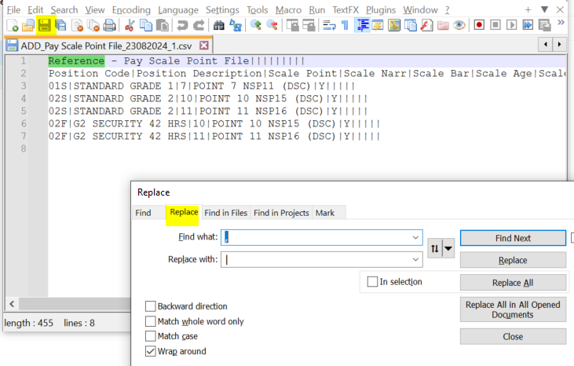
Navigation path: Administrator Dashboard> Data Migration> LOAD FILE (tile): Click on 
Column Heading | Description of entry to column
A: Position Code | New Position Code created in previous step or an existing code e.g. ‘01S’
B: Description | New Position Description created in previous step or an existing code e.g. ‘STANDARD GRADE 1’.
C: Scale Point | Populate with the Scale point that the rate is effective. This aligns with the NSP (National Spine Point), this follows the UoO (University of Oxford) agreed naming convention. E.g. ‘01’
D: Scale Narr | Populate with the Scale narrative. This has been agreed with the HRSEG and follows the UoO agreed naming convention (This includes the NSP) e.g. ‘POINT 1 NSP01 (DSC)’, the ‘(DSC)’ may include ‘(BAR)’ and then column E will need to be populated.
E: Scale Bar | The BAR point means the person doesn’t increment beyond this point automatically. It’s an automatic stop and requires user instruction to say employee should be incremented beyond this. e.g. Populate with ‘Y’ if this is a barrier point.
NOTE: For further fields and the full file format please see file: Data Load Upload Templates

Back-out Procedure
To back this file out, providing that no activity has taken place against the newly created Scale Points, it can be BACKED OUT quite quickly, using the Administrator Dashboard functionality:
- Click the ellipsis, on the Data Migration Option tile, at the end of the record that you wish to remove, select the ‘Clear Down’ option
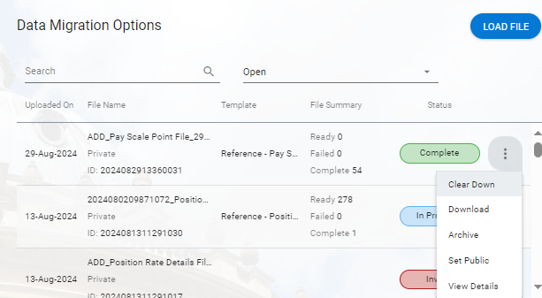
- Once the ‘Clear Down’ option has been selected, click on the ‘Yes’ option in answer to the question being asked.
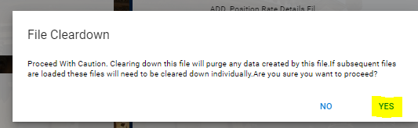
- Once this has completed backing out the loaded data it will return as completed.
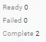
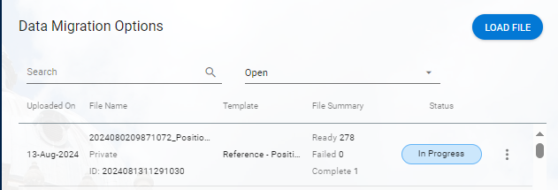

Upload Functionality - The columns required are for Position Rate Details File functionality:
This is an automated process where each field held in the excel spreadsheet, provided by the Analytics team, will be updated in PeopleXD following the Navigation route provided below
Points to consider before loading:
Navigation path: Payroll Dashboard> Uploads>’Load Position rates of Pay’ tile
Column Heading | Description of entry to column
A: Position Code | New Position Code created in previous step or an existing code e.g. ‘01S’
B: Scale Point | Populate with the Scale point that the rate is effective. This aligns with the NSP (National Spine Point), this follows the UoO (University of Oxford) agreed naming convention. E.g. ‘01’
C: Rate Sequence number | Always set to ‘1’
D: Date Effective | DDMMYYYY e.g. ‘01102024’
*E: Hourly Rate | Can be set to e.g. ‘£12.71’. Both column E and H are used at UoO. Define value, otherwise set to ‘0’ or leave null if not used
*F: Daily Rate | Define value, otherwise set to ‘0’ or leave null if not used
*G: Weekly Rate | Define value, otherwise set to ‘0’ or leave null if not used
*H: Annual Salary | Populated with Total annual salary value (Rate of Pay) for the effective date. NOTE the actual pay will be calculated automatically from the Annual salary value and the Pay Multiplier (field) set, e.g. ‘£1,000.00’. Define value, otherwise set to ‘0’ or leave null if not used
I: Unit Type | Define value, otherwise set to ‘0’ or leave null if not used

NOTE: The ‘Reference’ field is used to identify what and when the change was made, however the reference is limited to only being able to added 5 chars to a system generated pre-fix of ‘PAY9962’ and the UoO adds an extension of e.g. ‘OUW24’ (Oxford University Weighting Year 2024) depending on what data is being loaded, to be agreed with the Payroll Team. Limited to 5 characters. Please see screen shot below Fig 1.
Fig 1. Loading CSV file
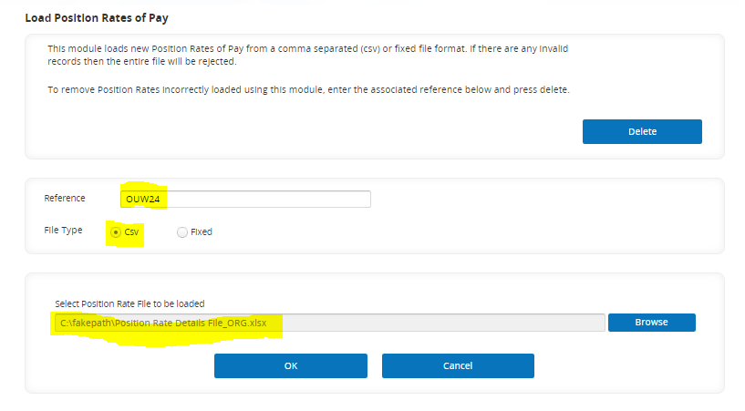
Make a note of this reference to use if you need to back-out this loaded file e.g. ‘PAY9962OUW24’.

Back-out Procedure
In-order to be able to back-out the file that had been previously loaded, provided that no records have been generated using the newly loaded data, then the file can be deleted using the ‘Delete’ button shown in Fig 2/3. In order to be able to delete the previously loaded file, it is imperative that the file name is retained, as it is this that will allow the deletion of that file via this functionality.
Fig 2. Deleting loaded file
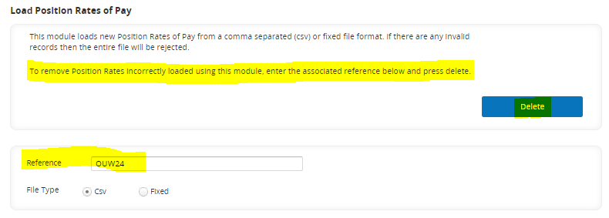
Fig 3. Deleting loaded file
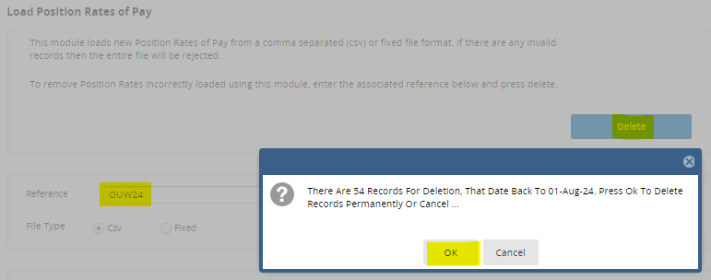

Upload Functionality - The columns required are for Employee New Rates of Pay functionality:

Personal Rates with spinal points between 1 to 9999 and 9999 are classed as spot salaries these all need to be uplifted. The HR Analytics Team will provide a list of all employees to be uplifted with the latest values; this can be loaded for all appointments using the ‘Load Employee rate file’ function in PeopleXD>Payroll Dashboard.

Pay uplift load (latest rates only) requires the following columns populated: A,B,C,D,E,J & L. Column K would only be populated if different reference required per record, otherwise it can be set on the load of the file.

Column Heading | Description of entry to column
A: Employee Number | Personnel number
B: Effective Date | Date the salary value is effective from. [Date format = DDMMYYYY]
C: New Position Code | Spot salary grade code
D: Scale Point | Always set to: from ‘1’ to ‘9999’. The Point at which the employee will start on the new Pay Scale/Grade.
E: Rate Sequence number | Always set to ‘1’
*F: Pay Multiplier | For Hourly Rate always ‘1’. This is the FTE multiplier that the FTE Salary will multiply. Can be in multiple decimal places
*G: Hourly Rate | Define value, otherwise set to ‘0’ or leave null if not used
*H: Daily Rate | Define value, otherwise set to ‘0’ or leave null if not used
*I: Weekly Rate | Define value, otherwise set to ‘0’ or leave null if not used
*J: Annual Salary | Populated with Total annual salary value (Rate of Pay) for the effective date. NOTE the actual pay will be calculated automatically from the Annual salary value and the Pay Multiplier (field) set. Define value, otherwise set to ‘0’ or leave null if not used
K: Reference | Populated for a historic load, with a real reason code. On uplift loads it can be set to the same value for all i.e. ‘PAYAWARDYY’ either within the file or setting a reference on the load itself. Make a not of this reference to use if you need to back-out this loaded filed.
L: Appointment ID | Populate with the Appointment ID for the salary row (this should allow secondary salaries to be uplifted as well as primary salaries) and will be provided by the Analytics Team.
*At least one of these fields must to be populate, NOT all.

NOTE: Some salaries will need to be manually keyed by Data Services where salary rows already exist for the effective date or later (see Appendix C for details on how to prepare both spot salary files).

Using this method you can only load a new uplifted salary rate of pay where a salary does not already exist for the effective date. Any corrections to uplifted salaries with the same effective date would need to be manually entered.

Prepare the load file as described in APPENDIX C.
When you are ready to upload the rates, navigate to:
Core|Portal>Payroll Dashboard>Uploads>Rate of Pay Uploads>Employee New Rates of Pay
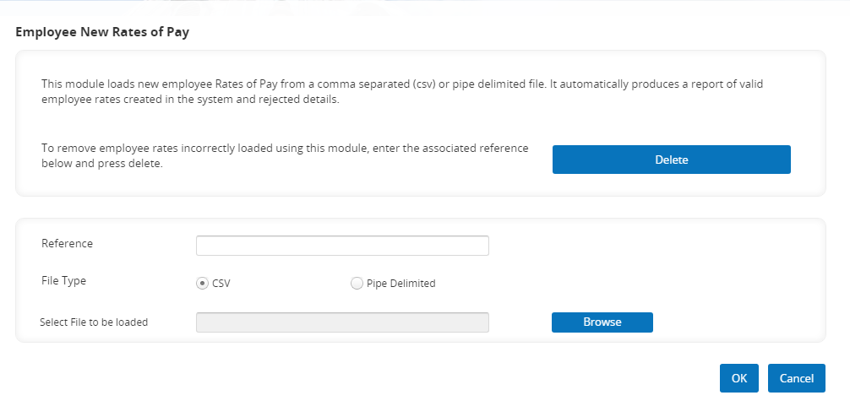

Enter the Reference for the whole file that will show on the Position History reference e.g. PAYAWARDYY – no spaces. Limited to 10 characters.

Click Browse and navigate to the location of your .CSV load file (or Pipe Delimited).

Click OK to begin the load process.
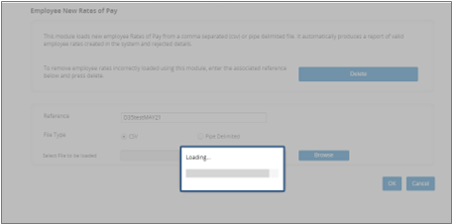
Once the process is complete, you will be asked to confirm and you will then receive the following message:
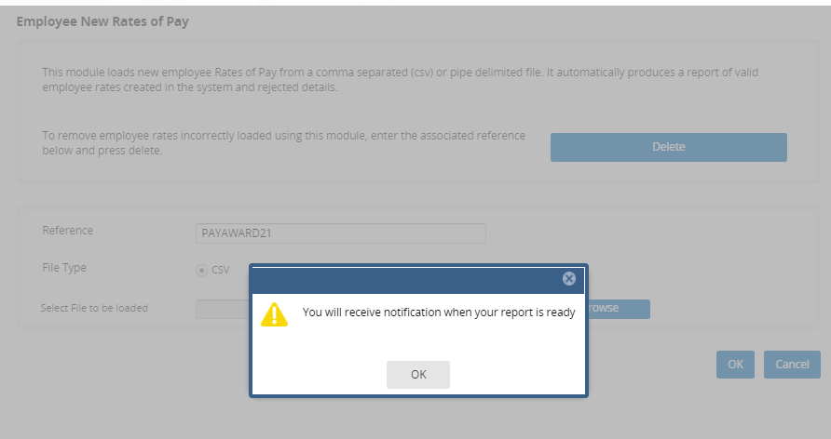

You may now navigate away from this screen and wait for the report to be prepared. You should then receive a notification in the system:
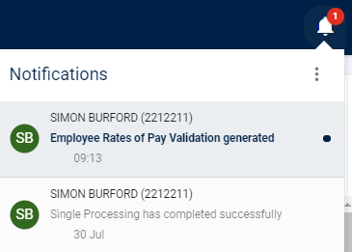

Navigate to the Report Centre within the payroll dashboard, expand the “Uploads” section and you will see the Employee Rates of Pay Validation file ready to download:
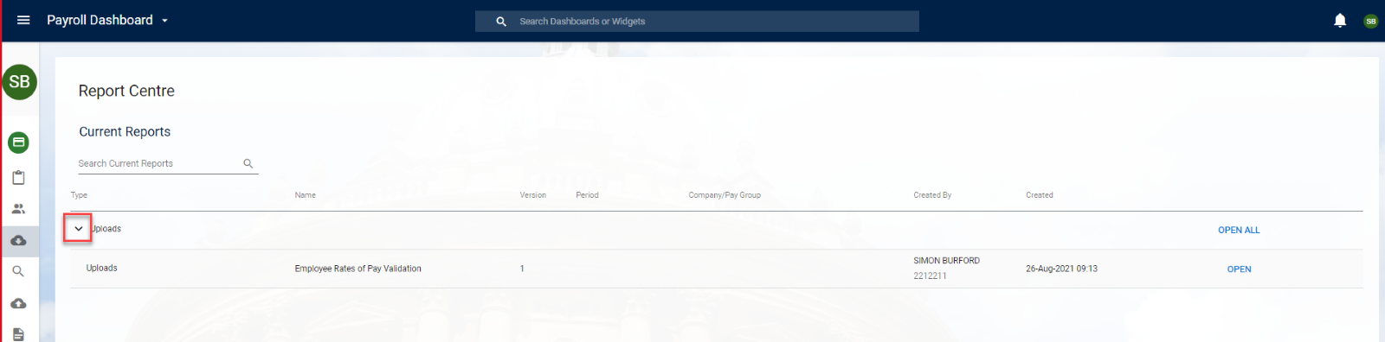

Click the Open button and review the report. The report should be saved for future reference, particularly for the production load. The report will show any invalid records under the “Invalid Employee Rate of Pay Details” section, if applicable, then will list all records that have been successfully uploaded under the “Valid Employee Rate of Pay Details loaded to Payroll” section. Review any invalid records and these may need to be added to the manual spot salary file.

NOTE: if you attempt to upload the rate of an employee who is not set up in payroll but is set up in people management the tool will load the rate against the people management record, however it is very unlikely you should be uploading a new rate for this type of record as part of the pay uplift so please query any records which appear in the “Valid Employee Rate of Pay Details loaded to Personnel” section.

Back-out Procedure
In-order to be able to back-out the file that had been previously loaded, provided that no records have been generated using the newly loaded data, then the file can be deleted using the ‘Delete’ button shown in Fig 1/2. In order to be able to delete the previously loaded file, it is imperative that the file name is retained, as it is this that will allow the deletion of that file via this functionality.
Fig 1. Deleting loaded file
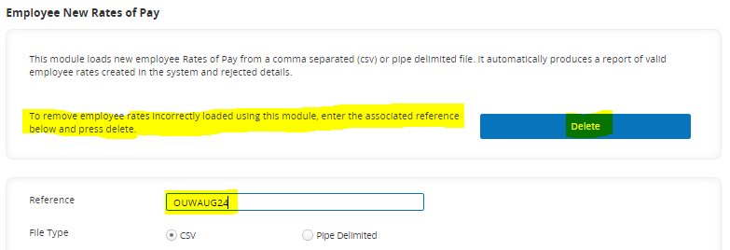
Fig 2. Deleting loaded file
